EECS 351

Introduction to Computer Graphics

Project B

Rotating Snowman Using WebGL

Instructor: Prof. John Timblin

Name: Ang Shen

NETID: asi031

02/26/2015

**Introduction**

In this project, a snow scene is drawn using WebGL and HTML-5 on a browser. Based on project A, snowman and a tree are drawn on the Canvas with animation, In addition to the project A, more optimized design is employed in this project such as 3D projection, lighting, updated window size and so on.

**User Guide**

Part I Without Control

The browser shows a snowman whose body and head turns around automatically with a constant speed. In addition, a tree is drawn on the Canvas as well. The tree rotates along z-axis over time. The size and the shape of the tree is changed over time as well. A snow background is loaded behind it. At the left side of the browser, build-in buttons and instructions for HELP manual will be shown as well.

Part II User Control

* On the left bottom of the screen, **<<Spin** and **Spin>>** will increase or decrease the spinning speed of the tree. Same functionality can be achieved by pressing **‘+’** and **‘-’** on the keyboard.
* **Tree View** and **Origin View** buttons are used to change the projection view between user and the top of the tree.
* Click **Run/Stop** is used to pause the snowman.
* Press **‘H’** key on the keyboard to get the brief user control manual.
* Press **Up, Down, Left, Right** to control look at point.
* Press **W** and **S** to move camera forward and backward.
* Press **A** and **D** to move camera left and right.
* Press **Q** and **E** to move camera up and down.
* Drag mouse to move the snowman.

**Scene Graph**

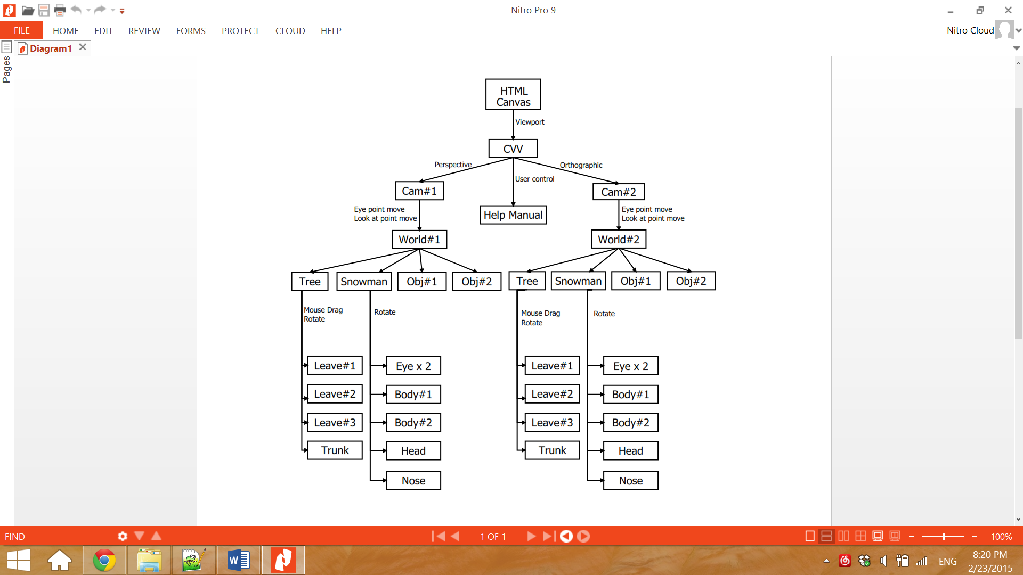

**Results**

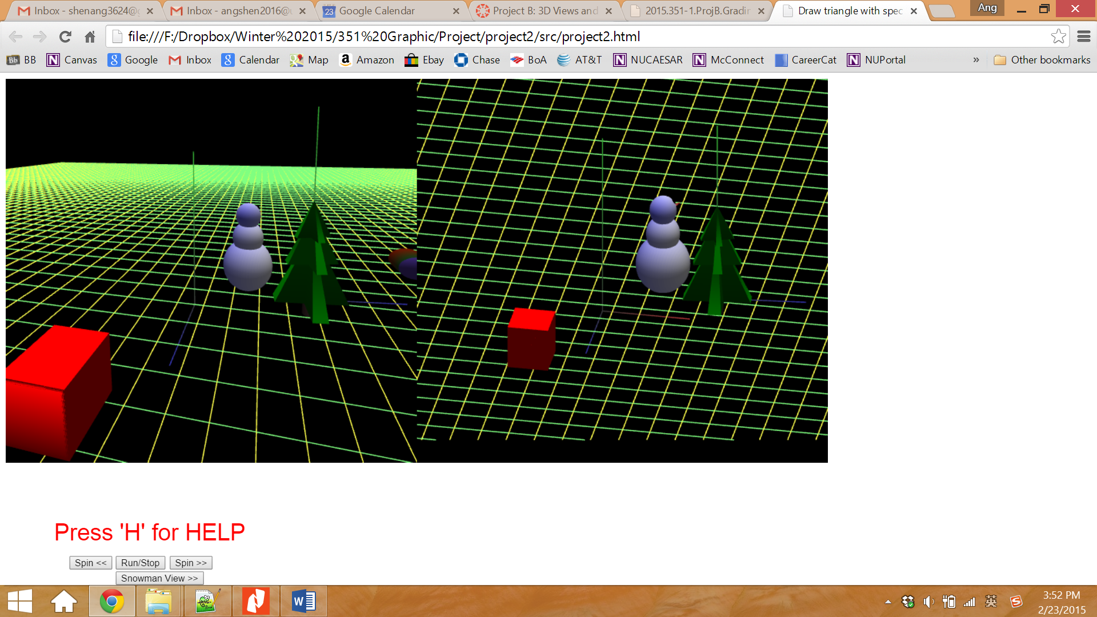

Figure 1. Initial Page

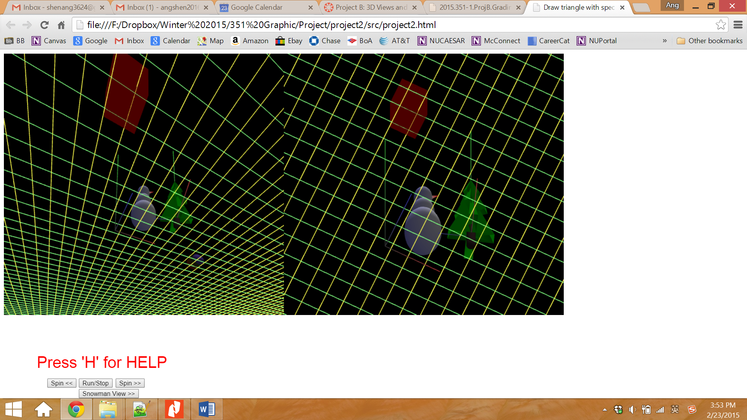

Figure 2. Scene after moving camera

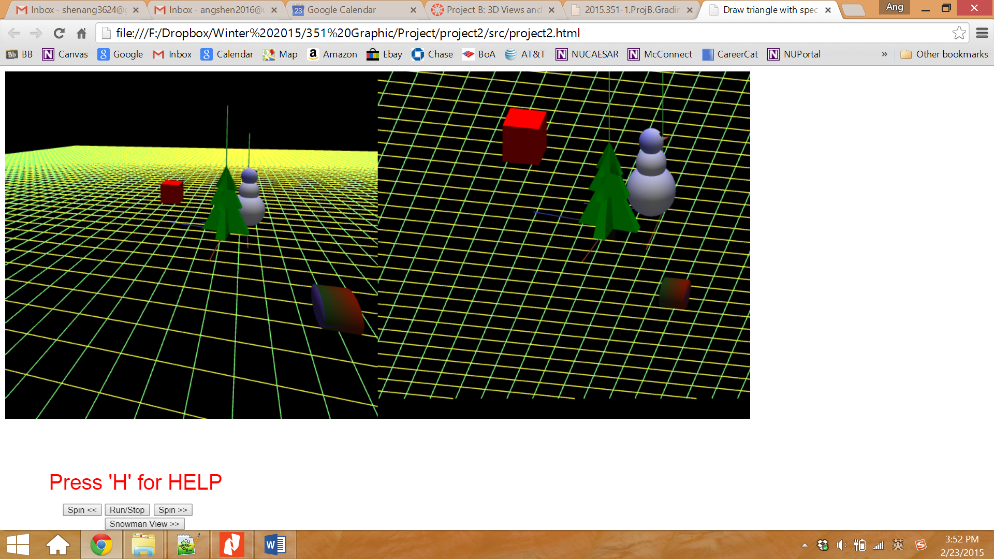

Figure 3. Scene after moving camera

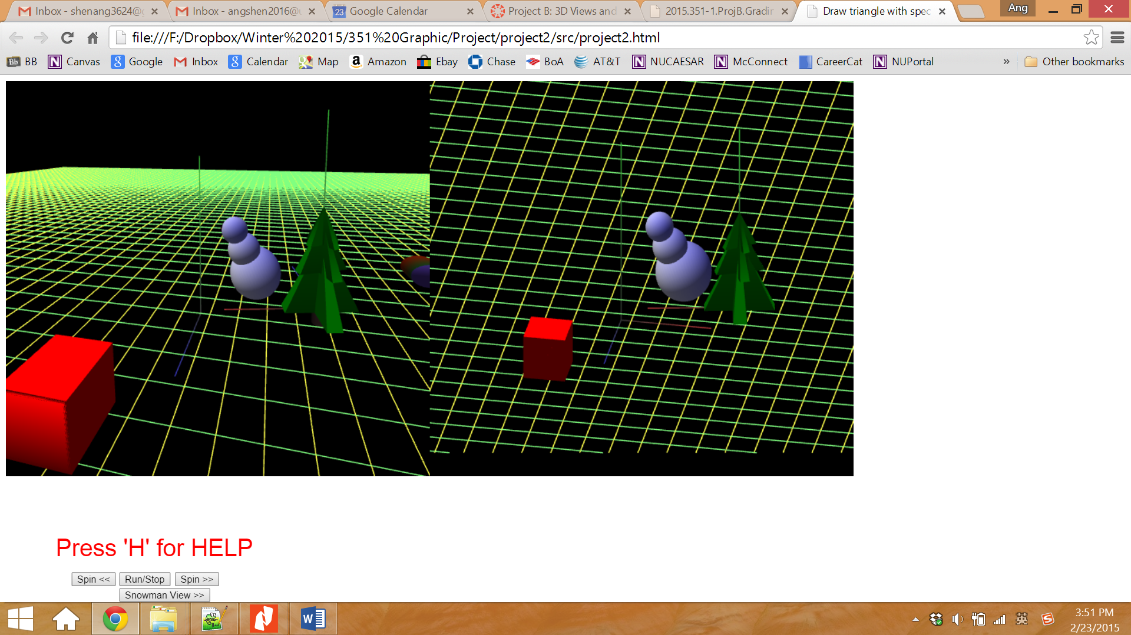

Figure 4. Snowman after moved by dragging mouse

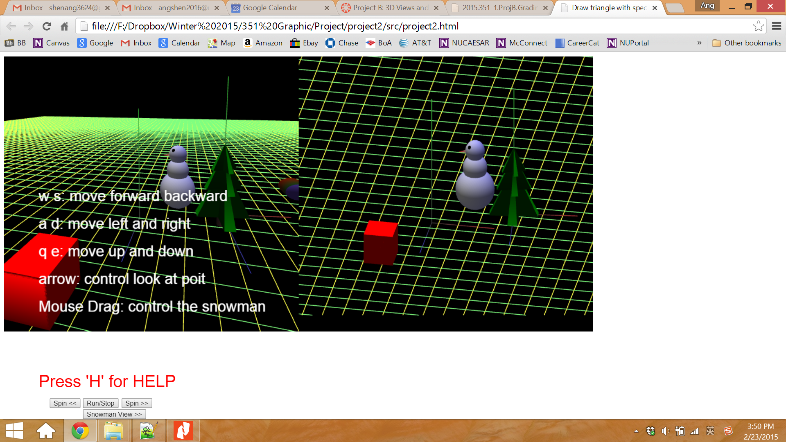

Figure 5. User guide popped up when **‘H’** is pressed

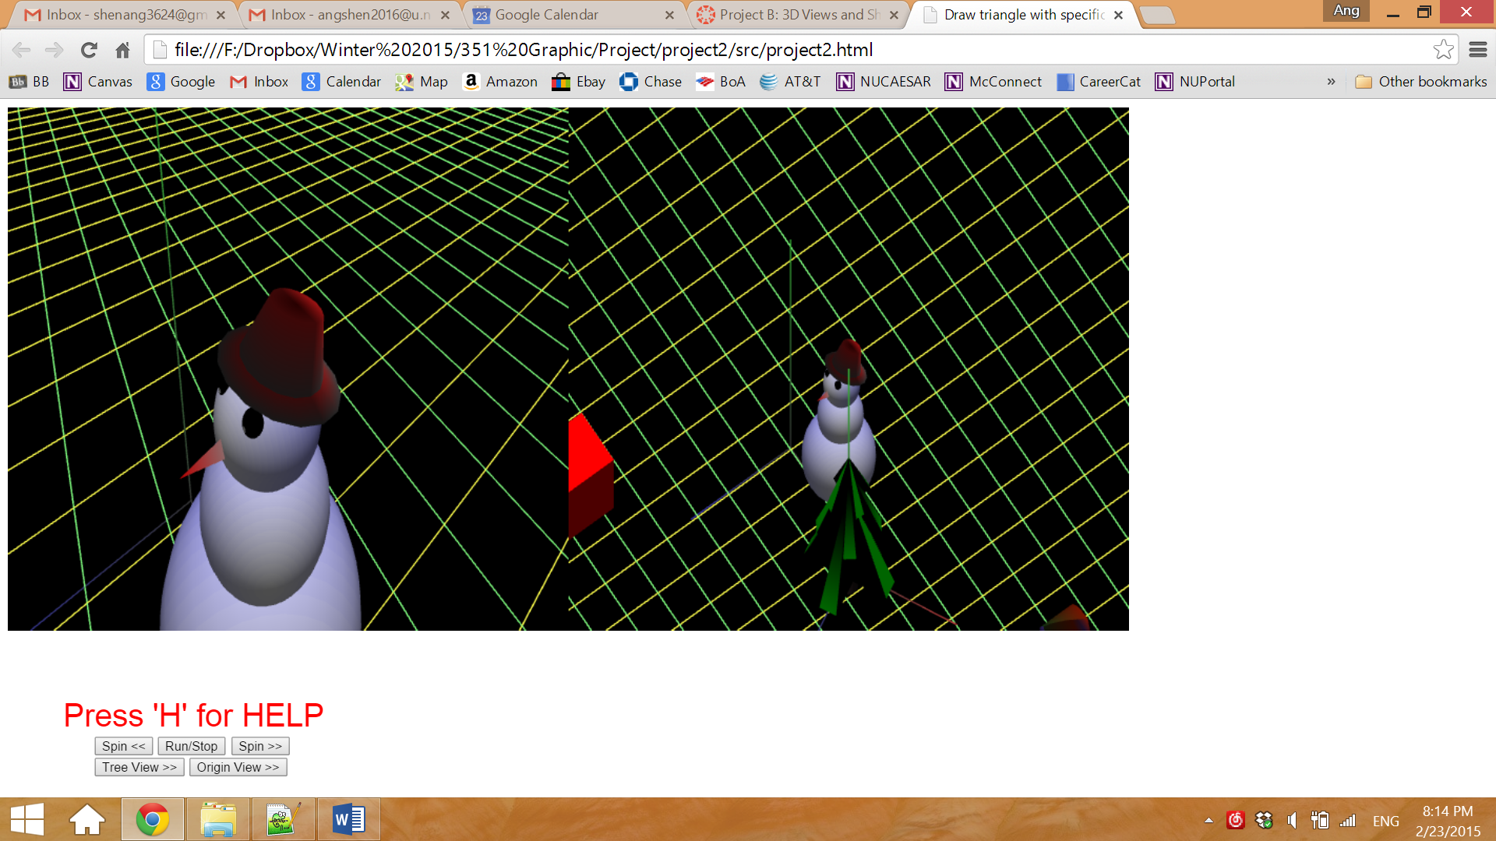

Figure 6. Projection view of the top of the tree